**Tasks on RDS**

1) Create MariaDB db on ec2.

We are using these commands to install MariaDB in ec2.  
  
**sudo su** - - Switch to root user for administrative privileges

**yum -y install mariadb-server wget** - Install MariaDB server and wget

**systemctl enable mariadb** - Enable MariaDB service to start automatically

**systemctl start mariadb** - Start MariaDB service

**yum -y update** - Update packages to ensure latest versions

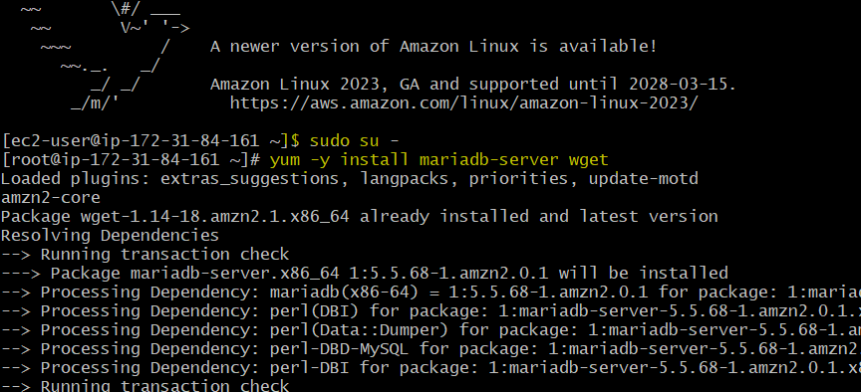

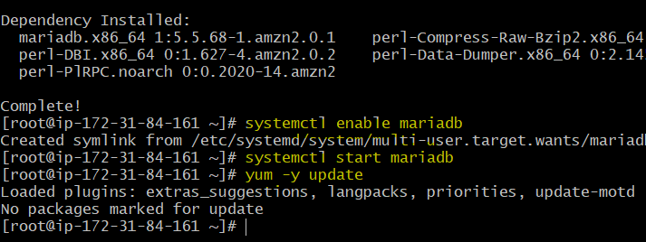

Set Environmental Variables (Valid for single session)

===========================

**DBName=ec2db**

**DBPassword=admin123456**

**DBRootPassword=admin123456**

**DBUser=ec2dbuser**

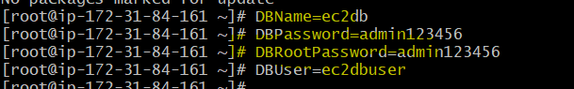

**To create database**,

**echo "CREATE DATABASE ${DBName};" >> /tmp/db.setup** - Create database

**echo "CREATE USER '${DBUser}' IDENTIFIED BY '${DBPassword}';" >> /tmp/db.setup** - Create user

**echo "GRANT ALL PRIVILEGES ON *.* TO '${DBUser}'@'%';" >> /tmp/db.setup** - Grant privileges

**echo "FLUSH PRIVILEGES;" >> /tmp/db.setup** - Apply changes

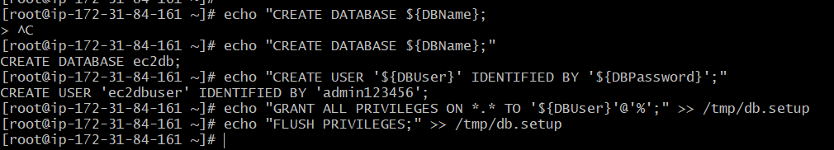

**mysqladmin -u root password "${DBRootPassword}"** - Set root password

**mysql -u root --password="${DBRootPassword}" < /tmp/db.setup** - Execute database setup

**rm /tmp/db.setup** - Remove temporary setup file from local

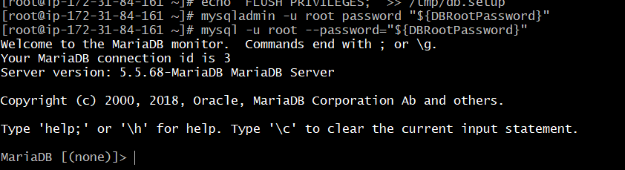



2) Insert some dummy data

**sudo mysql -u root -p** – To login in DB.

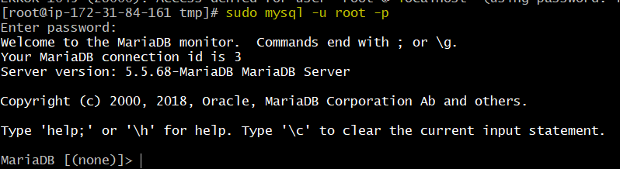

**show databases; -** To check available DB’s.  
  
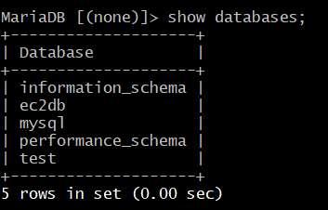

**USE ec2db**; - Switch to ec2db database

**CREATE TABLE table1 (id INT, name VARCHAR(45));** - Create a table

**INSERT INTO table1 VALUES(1, 'Head'), (2, 'Abhishek'), (3, 'kishan'), (4, 'klassen');** - Insert dummy data

**SELECT * FROM table1;** - Verify data

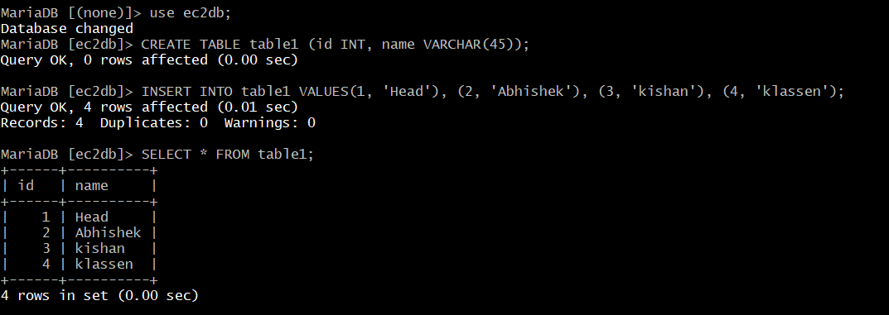

3) Take the backup of dummy data on ec2

**mysqldump -u root --password="${DBRootPassword}" ec2db > ec2db_backup.sql** - Create a backup of the database(Run command in ec2)



4) launch MariaDB RDS instance.

1. Sign in to AWS Management Console.  
2. Go to RDS Dashboard.

3. Click "Create database".

4. Choose "MariaDB" as the database engine.

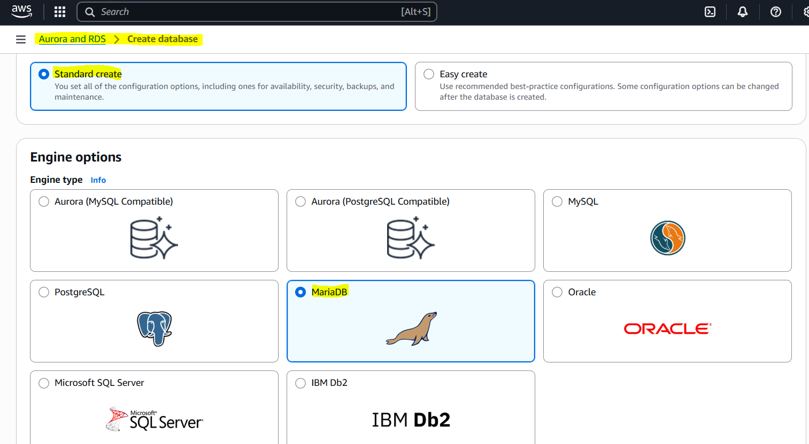

5. Configure instance settings (e.g., instance type, username, password).

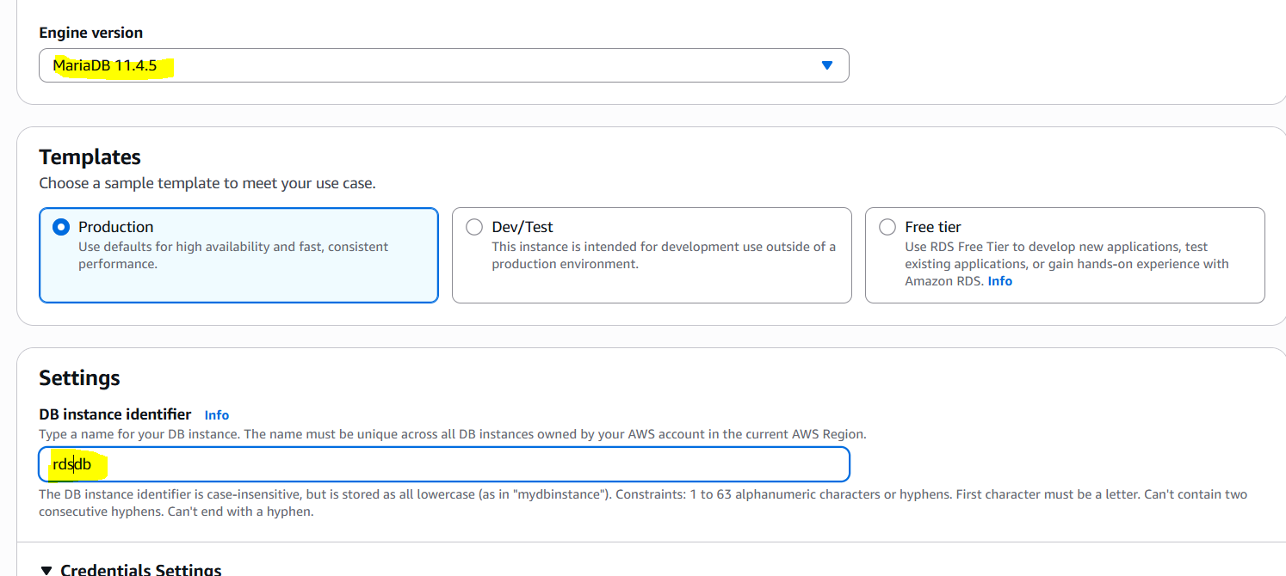

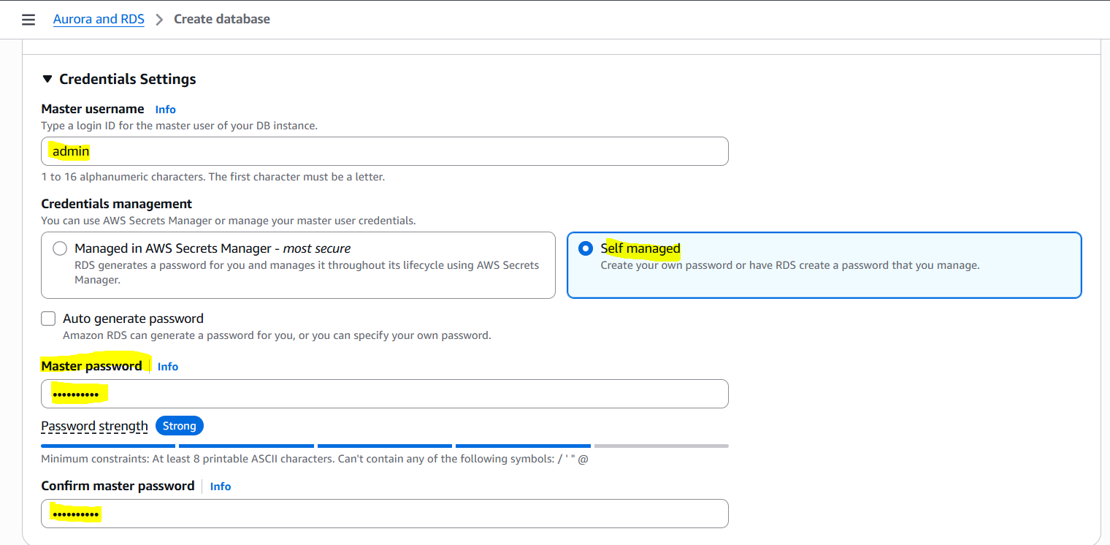

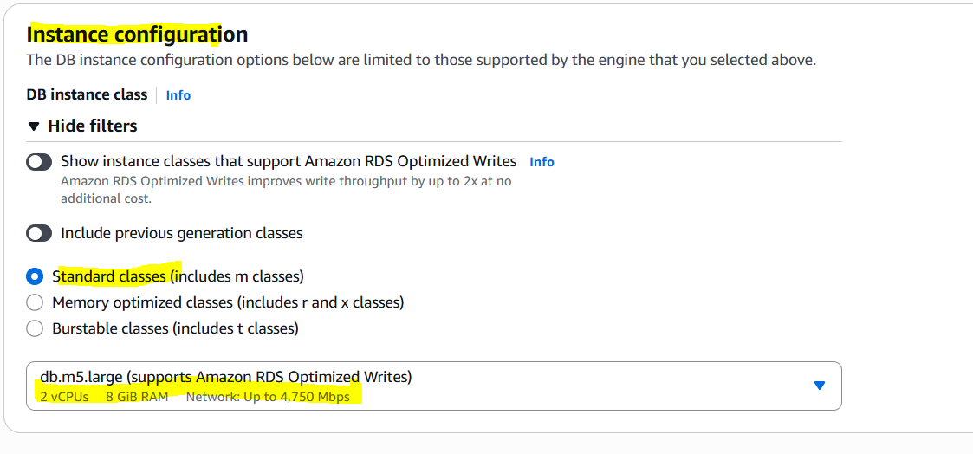

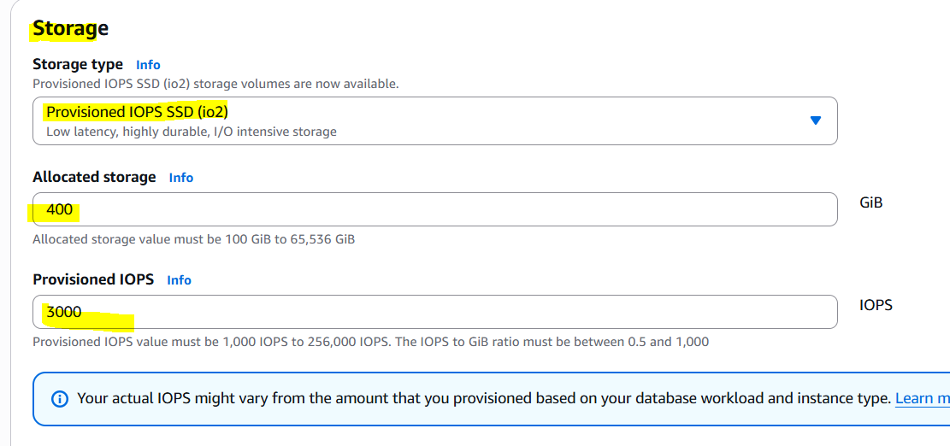

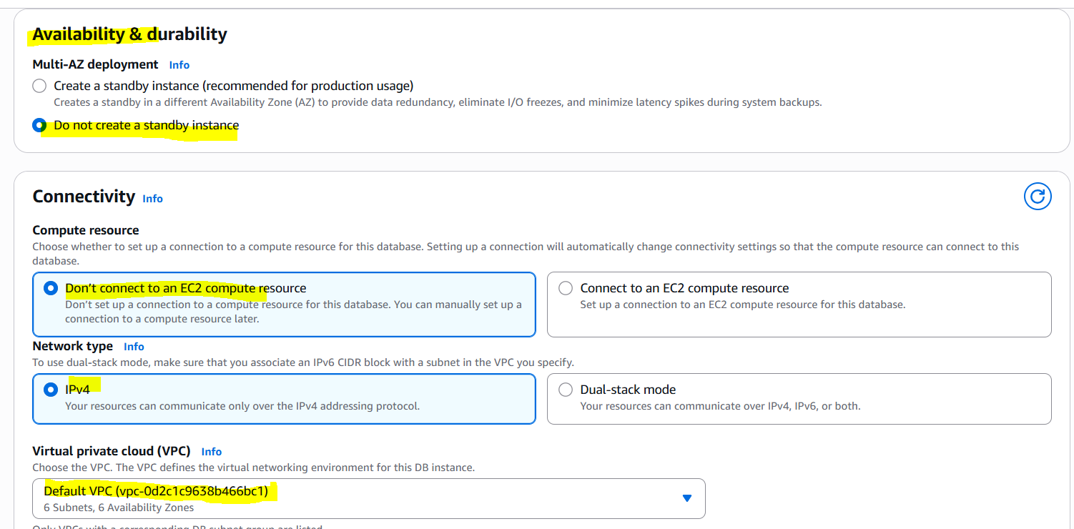

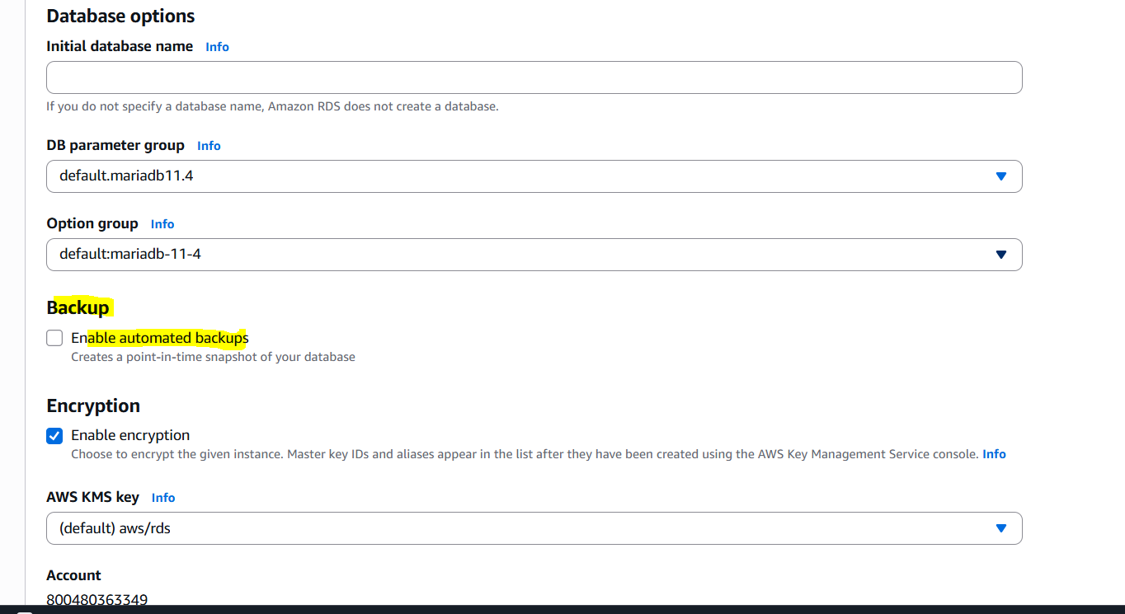

6. Click "Create database".

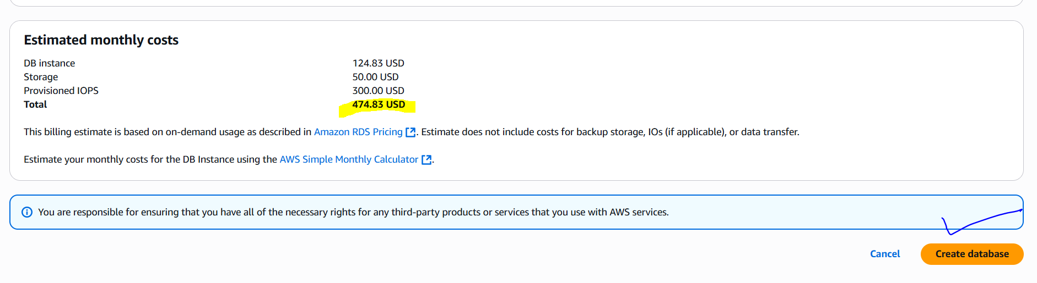

7. Wait for instance to become available.

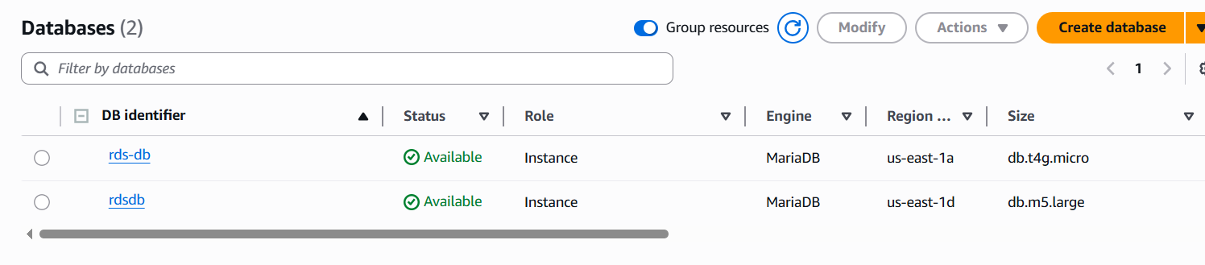

5) Migrate database from ec2 to RDS.

Migrating DB from EC2 to RDS:

============================

1) Migrate the DB dump that you have taken in step 1 to RDS

**mysql -h <replace-rds-end-point-here> -P 3306 -u <user_name> -p database_name < ec2db.sql**

2) Connect to your RDS DB instance

**mysql -h <replace-rds-end-point-here> -P 3306 -u rdsuser -p**

3) Switch to the database and verify the details.

**USE rdsdb**

**SELECT * FROM table1;**

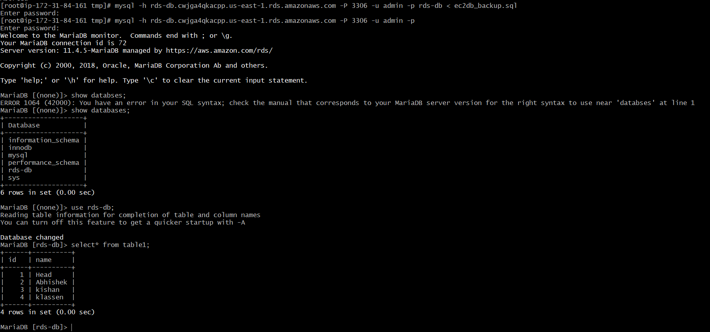

6) Install MySQL db on ec2

To install MySQL on an EC2 instance running Amazon Linux 2, first the MySQL repository is added using the command:

**wget https://dev.mysql.com/get/mysql57-community-release-el7-11.noarch.rpm  
rpm -ivh mysql57-community-release-el7-11.noarch.rpm**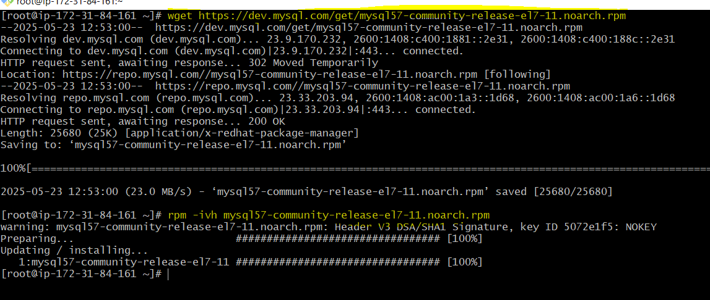

After adding the repository, MySQL is installed using:

**yum install -y mysql-community-server**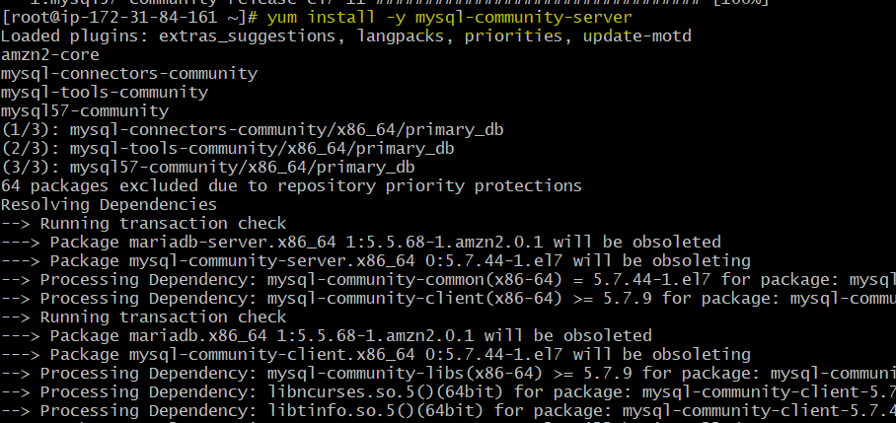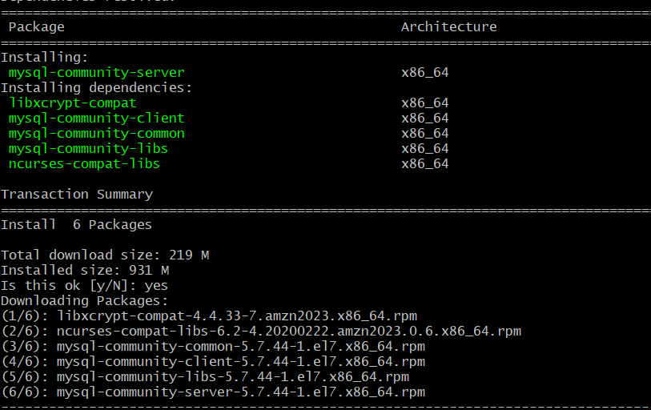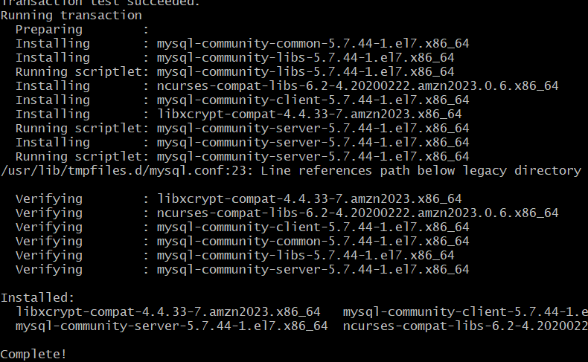

Once installed, the MySQL service is started with:

**systemctl start mysqld**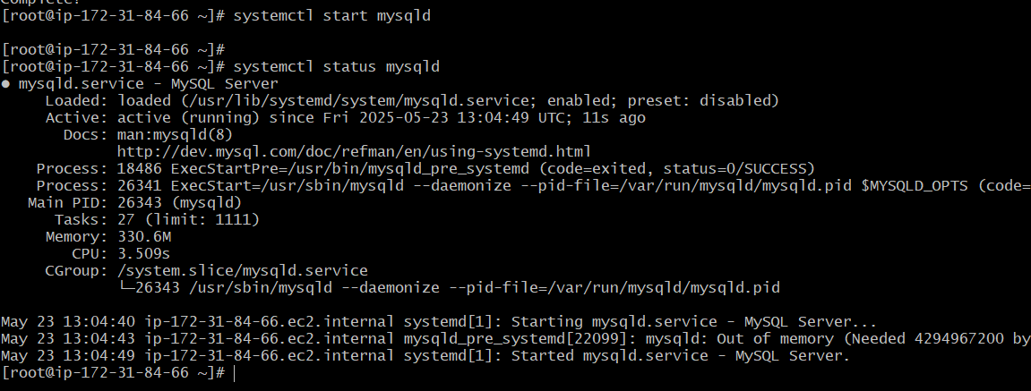

To make sure MySQL starts automatically after reboot, this command is used:

**systemctl enable mysqld**

The status of the MySQL service is checked with:

**systemctl status mysqld**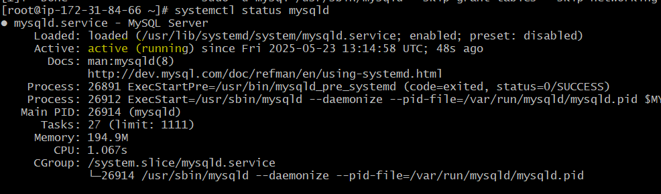

Finally, to log in to the MySQL server as root, the following is used:

**mysql -u root -p**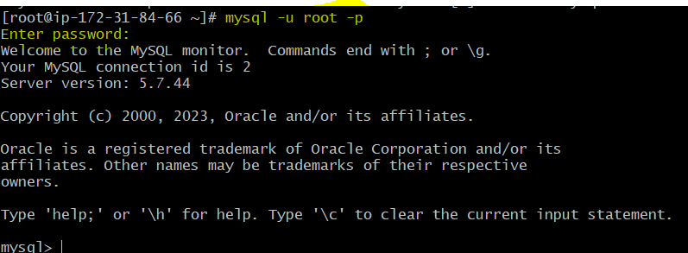

7) Launch MySQL RDS image

Open AWS RDS Console.  
Click **Create database**.  
Choose **Standard Create** and select **MySQL**.  
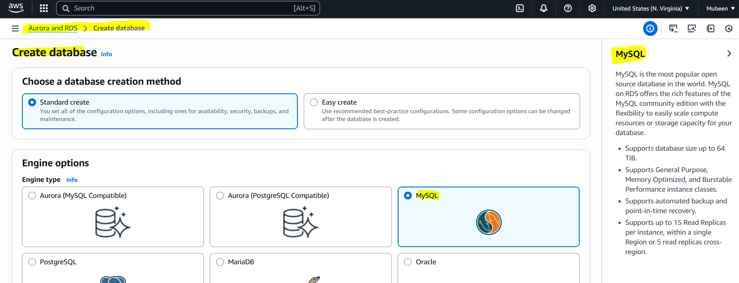  
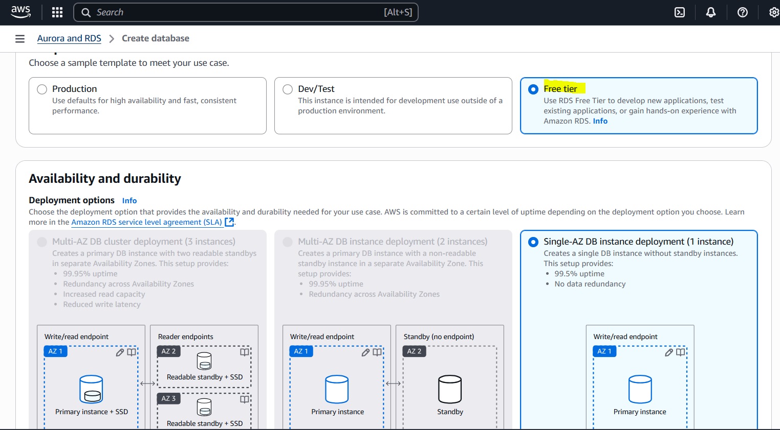

Enter DB name, username (e.g., admin), and password.  
  
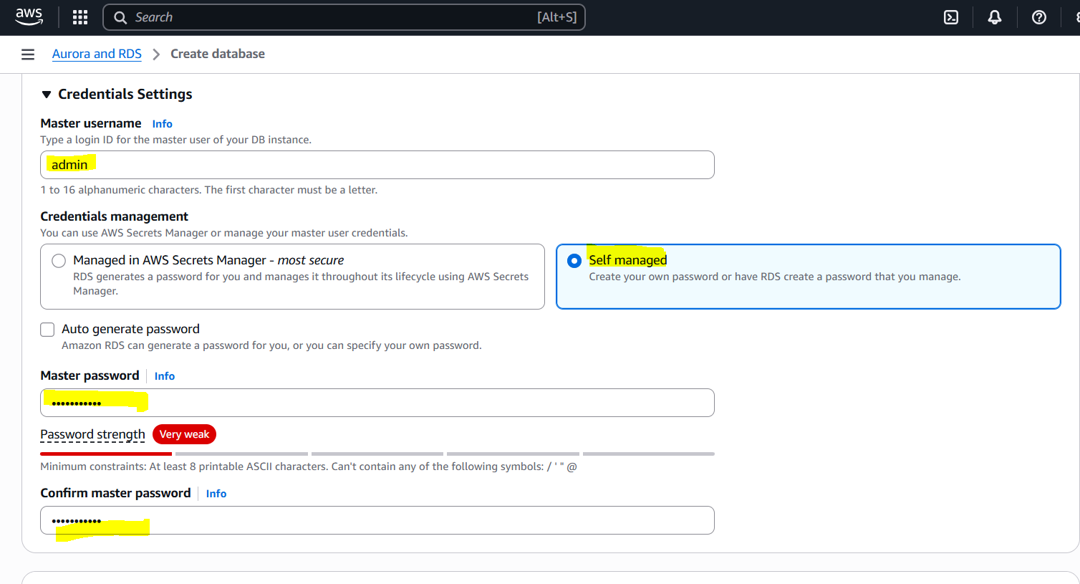

Choose instance size (like db.t3.micro).  
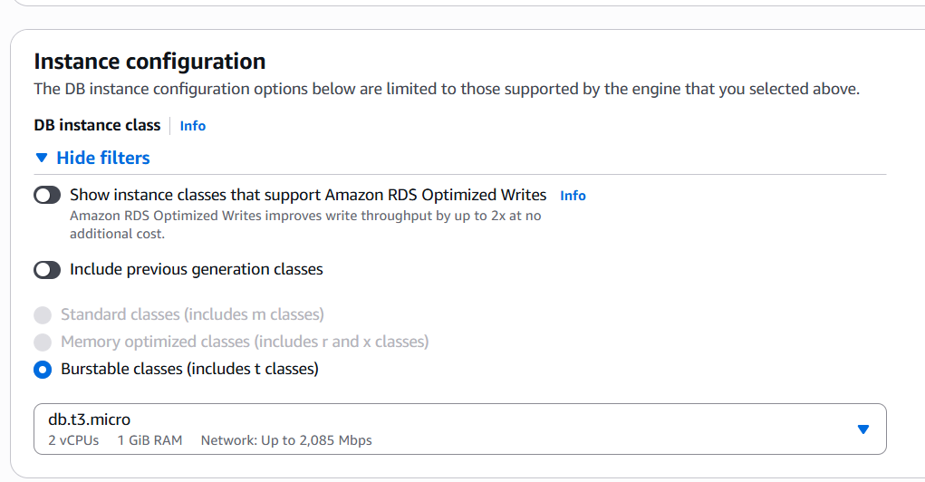

Set storage (e.g., 20 GB).  
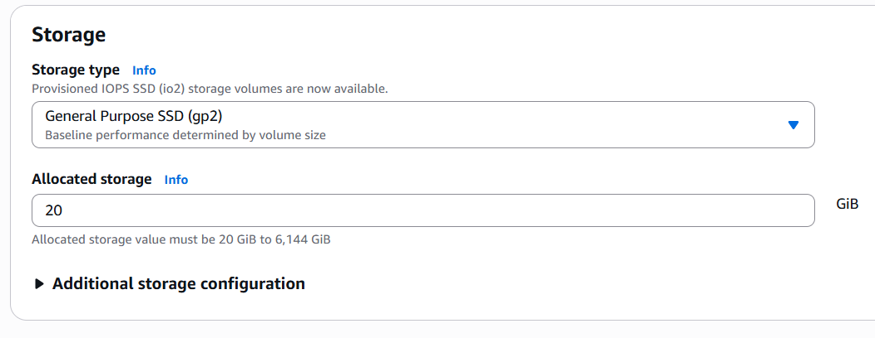

Choose **Enable automatic backups** (required for read replica).  
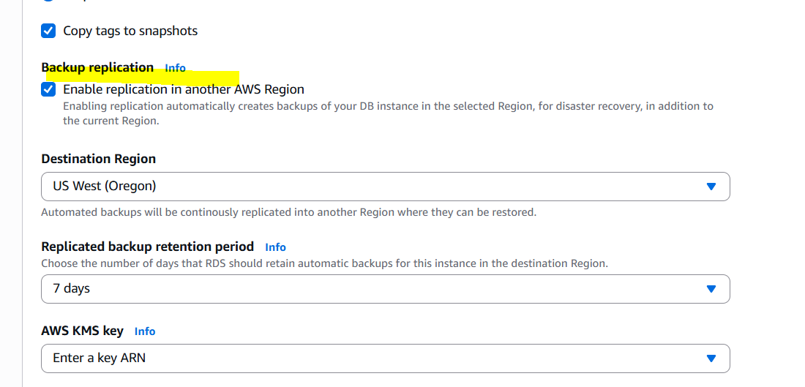

Set VPC and security group to allow port 3306.  
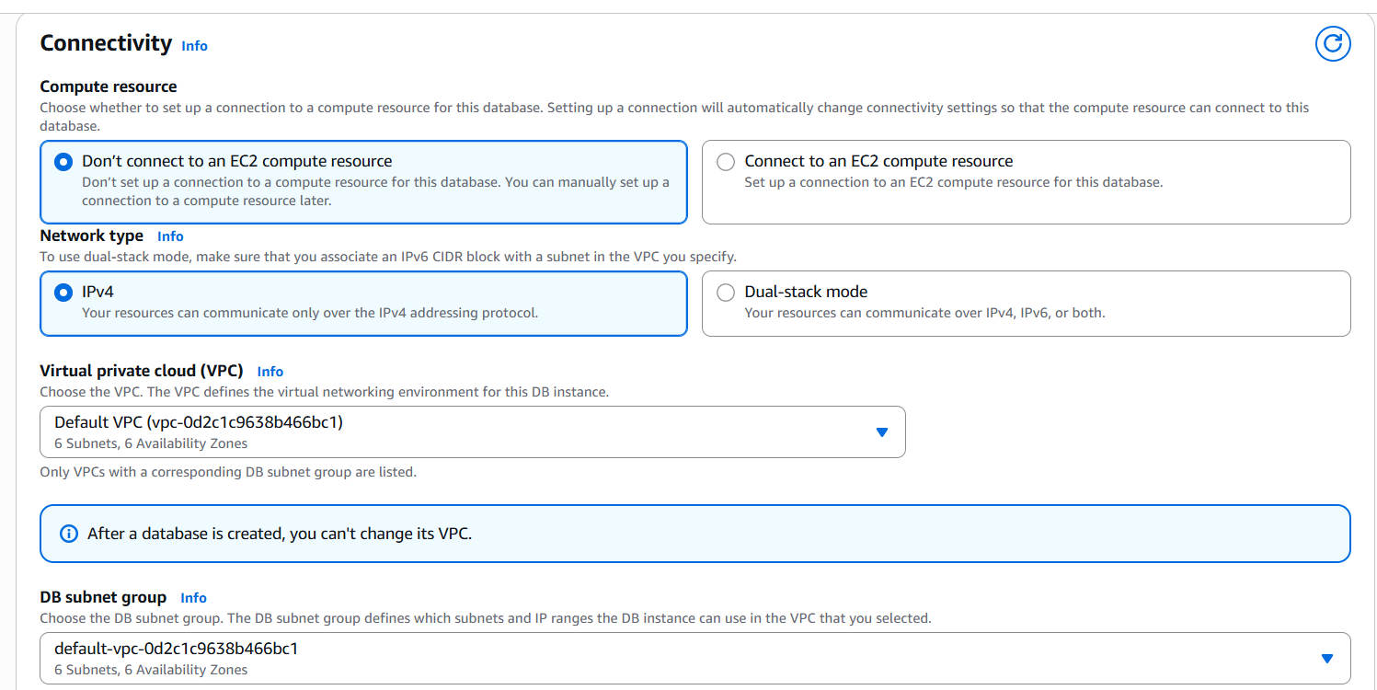

Click **Create database**.  
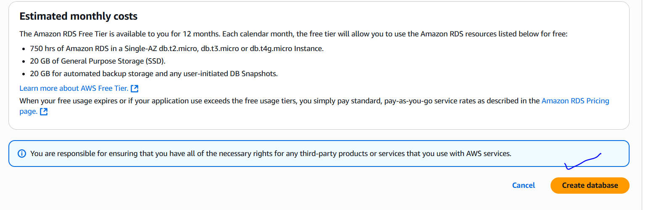

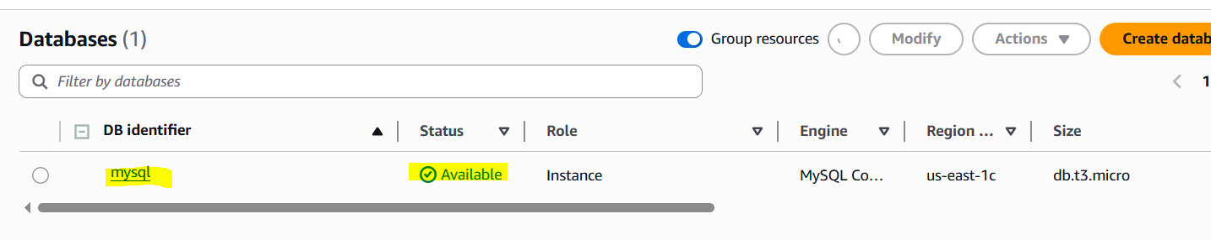

We can verify by login.  
 using command **mysql -h mysql.cwjga4qkacpp.us-east-1.rds.amazonaws.com -P 3306 -u admin -p**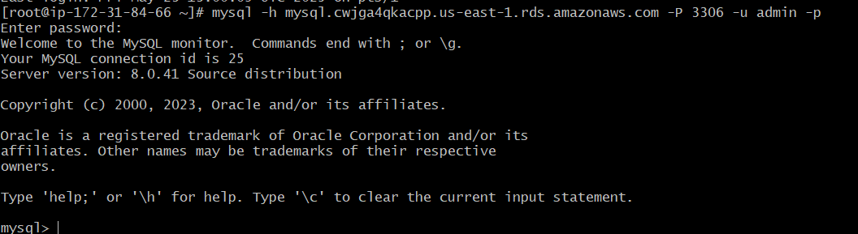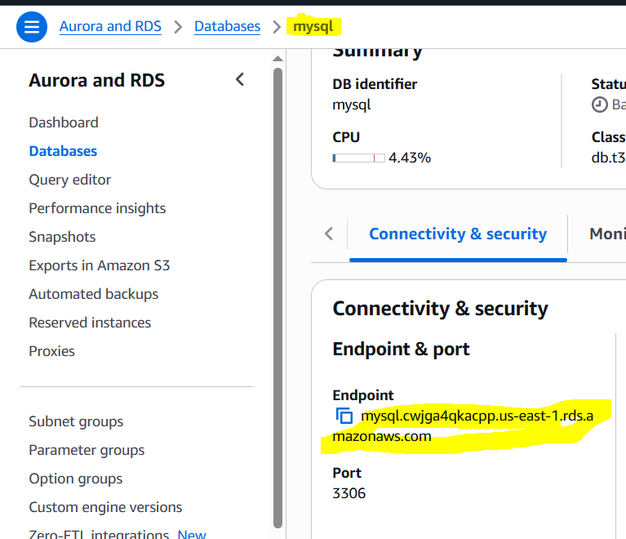

8) Configure multi AZ

1. Go to RDS Dashboard.

2. Select RDS instance.

3. Click "Actions" > " **Convert to Multi-AZ DB instance deployment** ".

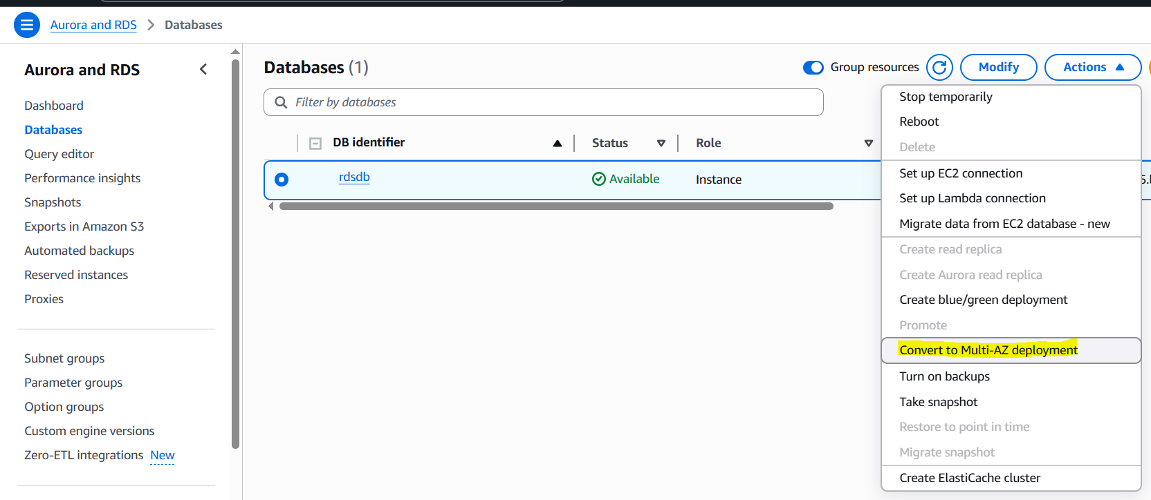

4. Enable "Multi-AZ deployment".

5. Apply changes.

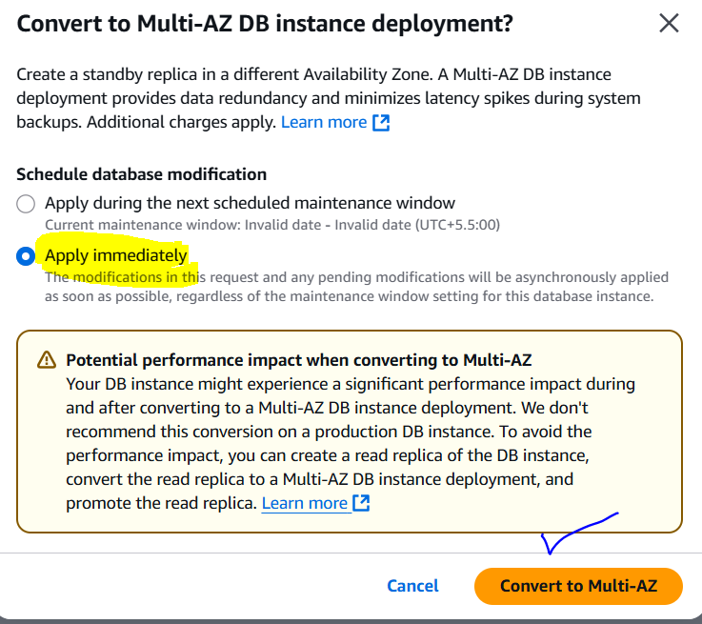

Takes long time to modify.

**Verify Multi-AZ Configuration:**

1. Go to RDS Dashboard.

2. Select RDS instance.

3. Check the "Availability & durability" section.

4. Verify that "Multi-AZ" is set to "Yes" and shows a standby instance in a different Availability Zone (AZ).

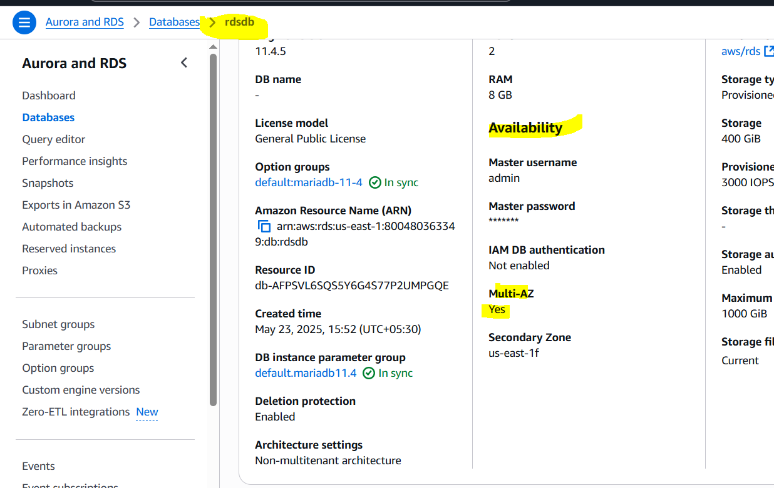

9) Take Backup of db and restore the DB

**Take Backup:**

1. RDS Dashboard > Databases.

2. Select instance > Actions > Take snapshot.

3. Enter snapshot identifier.

4. Click "Take snapshot".

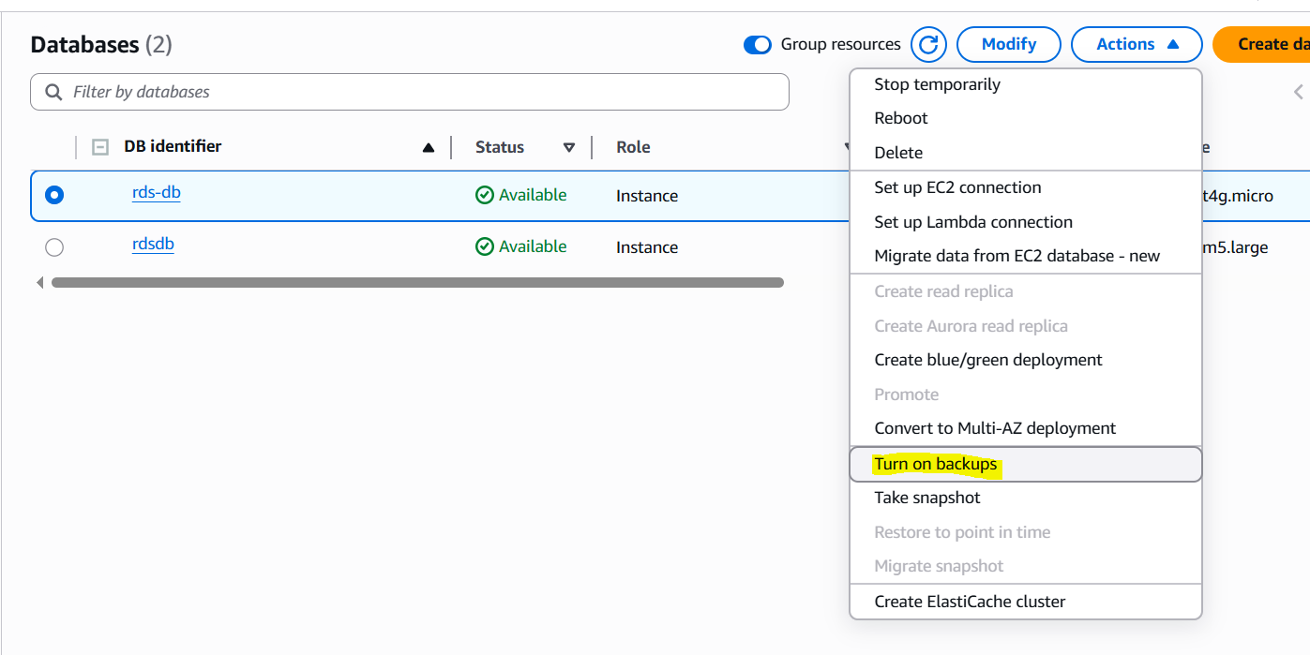

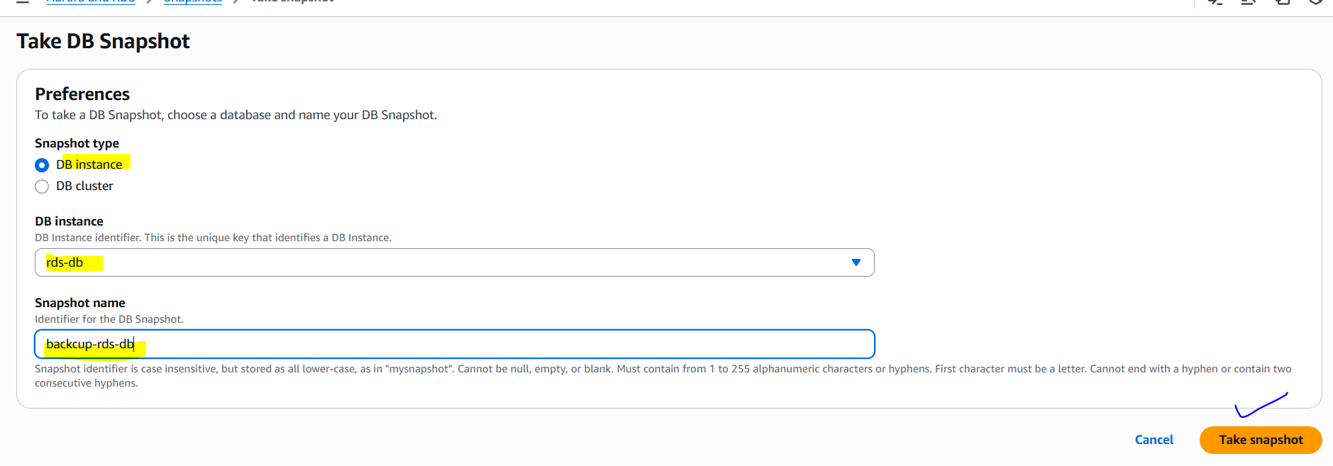

**Restore DB:**

1. RDS Dashboard > Snapshots.

2. Select snapshot > Actions > Restore snapshot.

3. Choose instance settings.

4. Click "Restore DB instance".

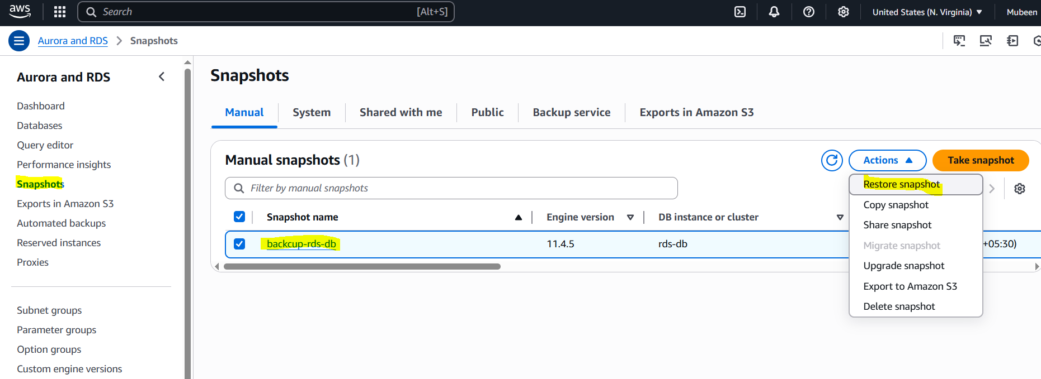

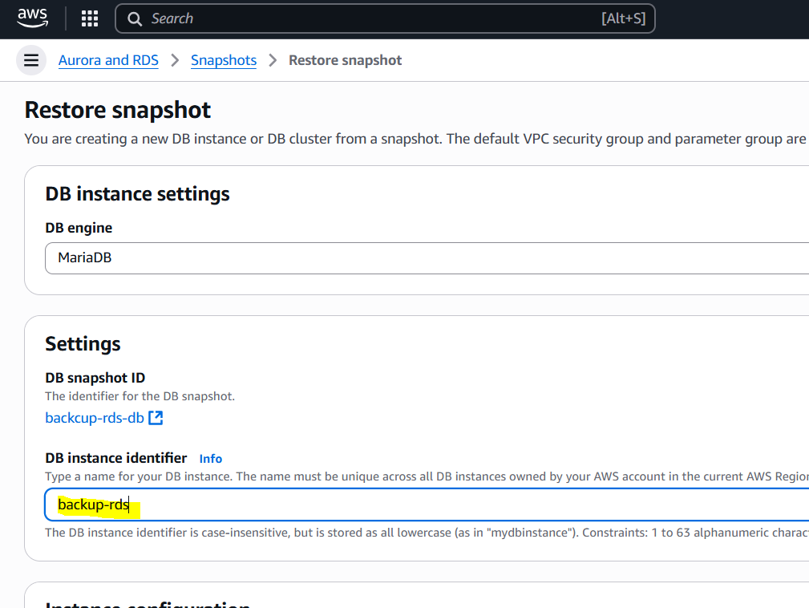

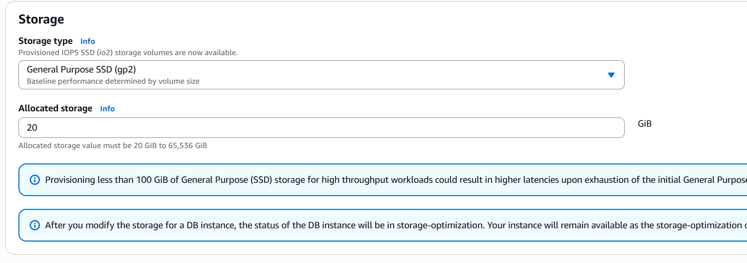

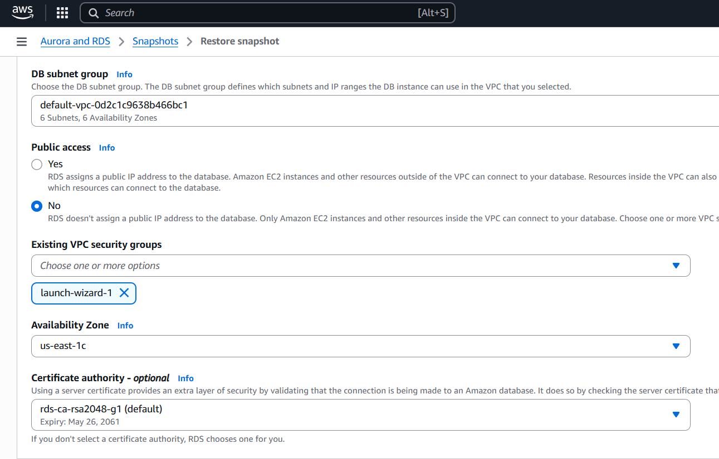

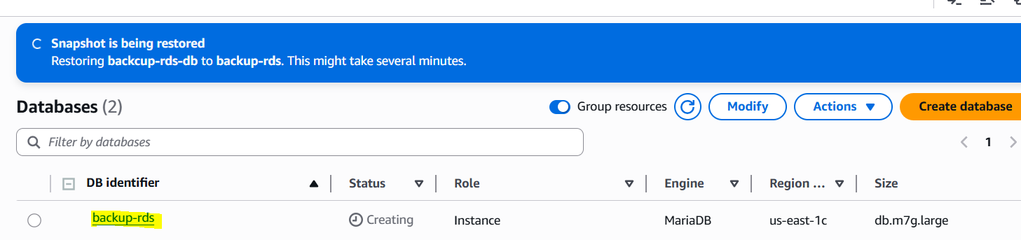

We can **verify** by checking the previously added data by using command,  
**mysql -h <replace-rds-end-point-here> -P 3306 -u rdsuser -p**

**USE rdsdb**

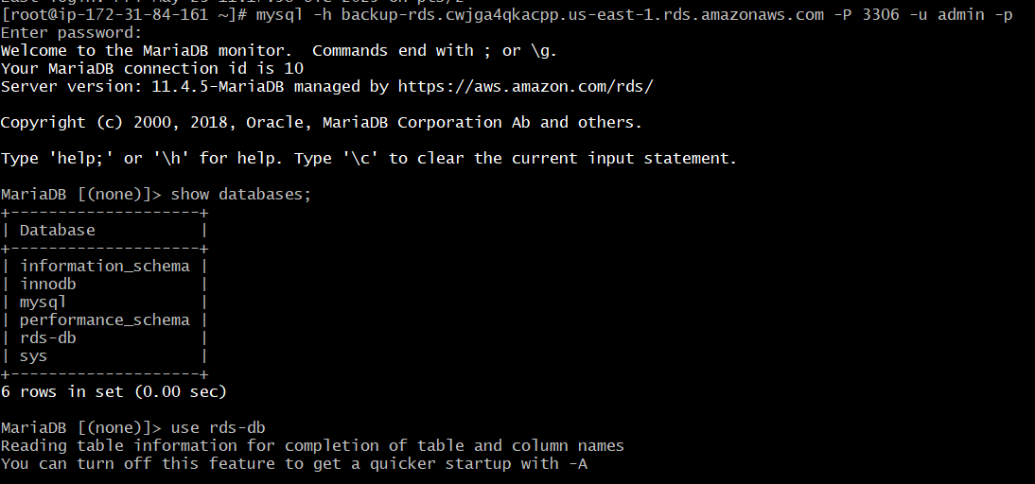

**SELECT * FROM table1;**

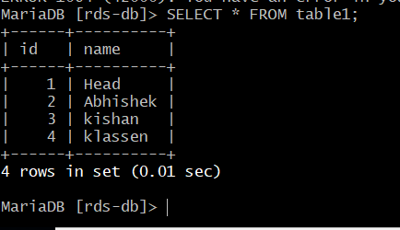

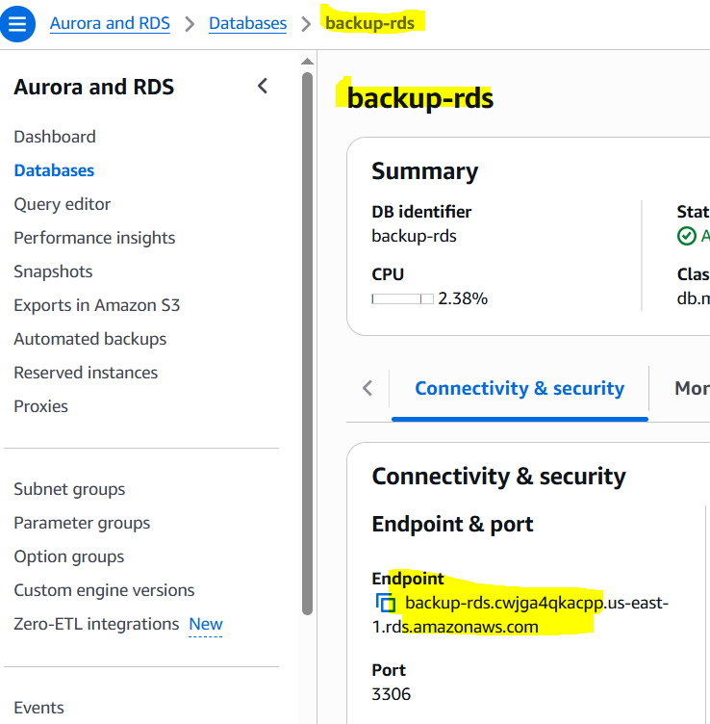

Endpoint is used for log in

10) Create Read Replica  
  
To create Read replica Backup must be enabled.

Click **Actions > Create read replica**.  
  
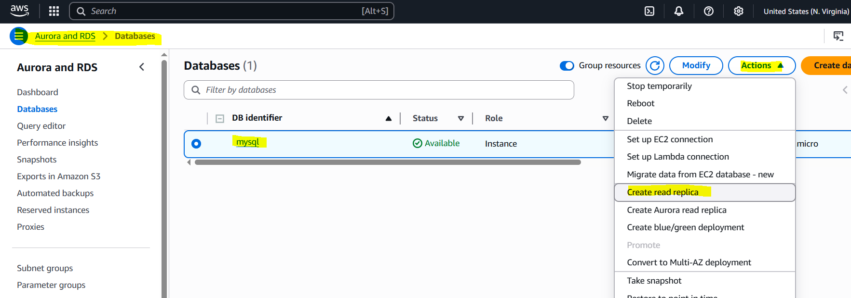

Choose instance class and settings, then create.

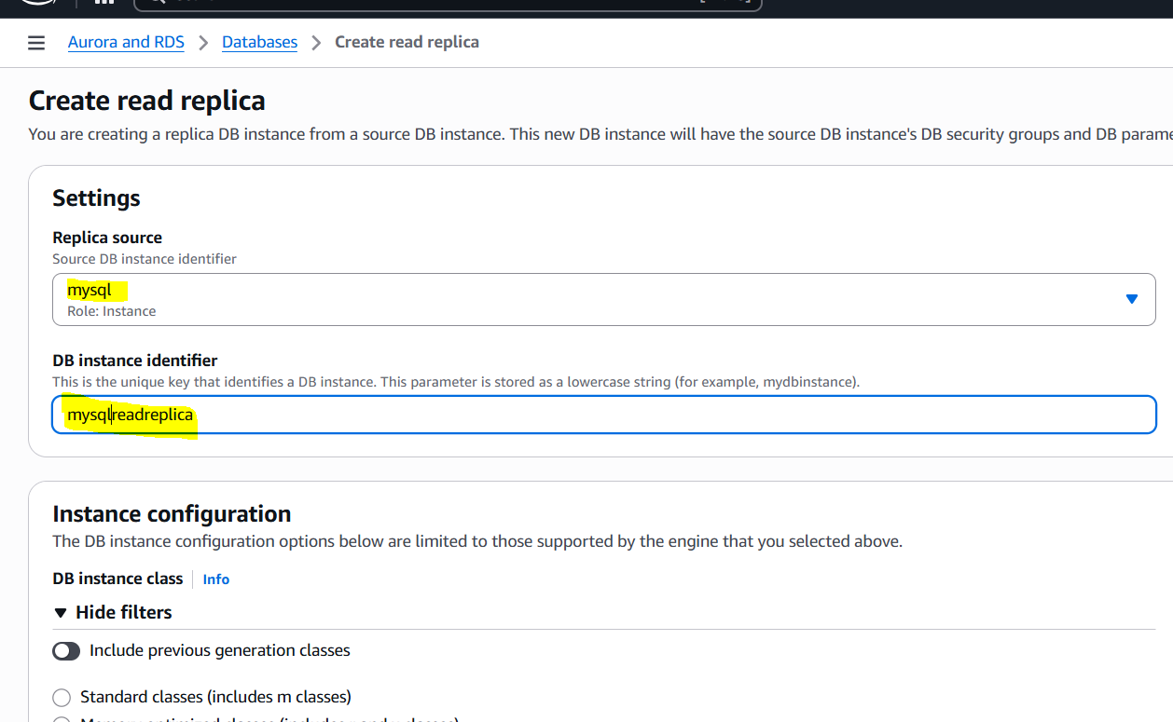  
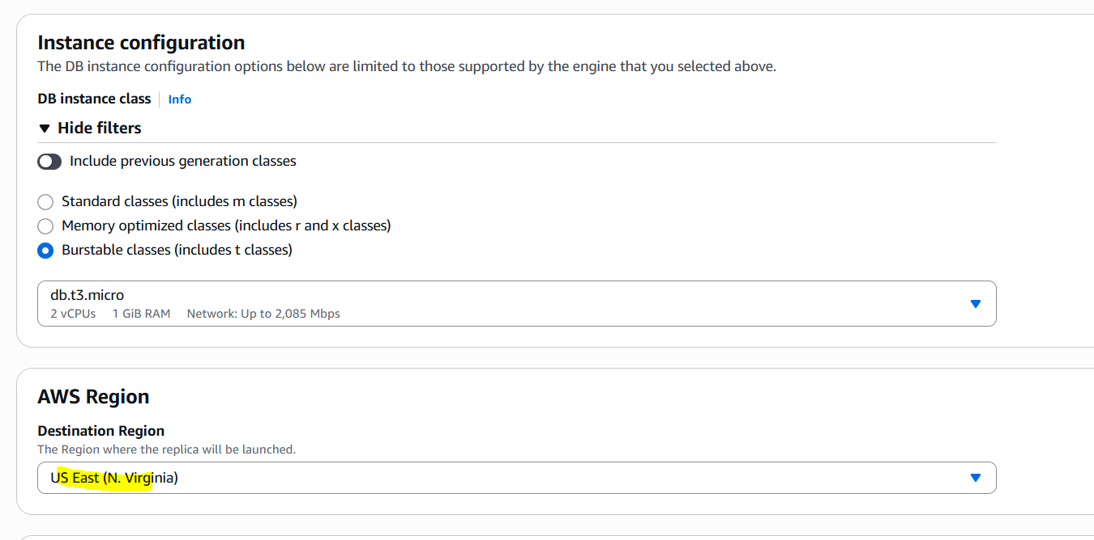  
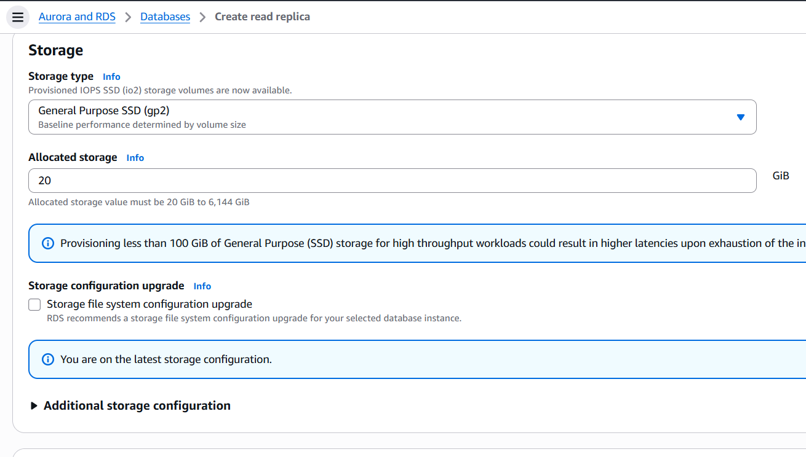  
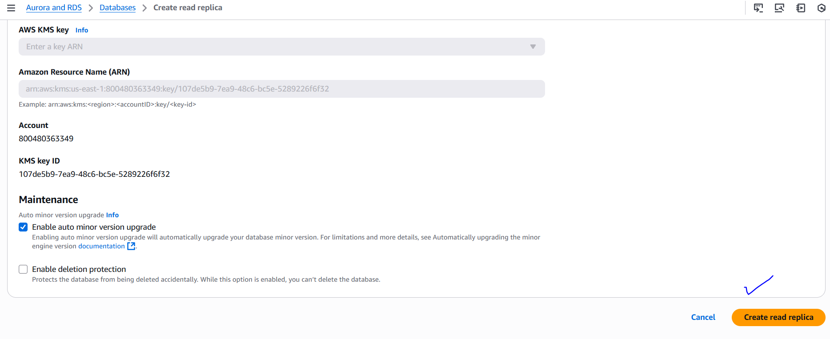  
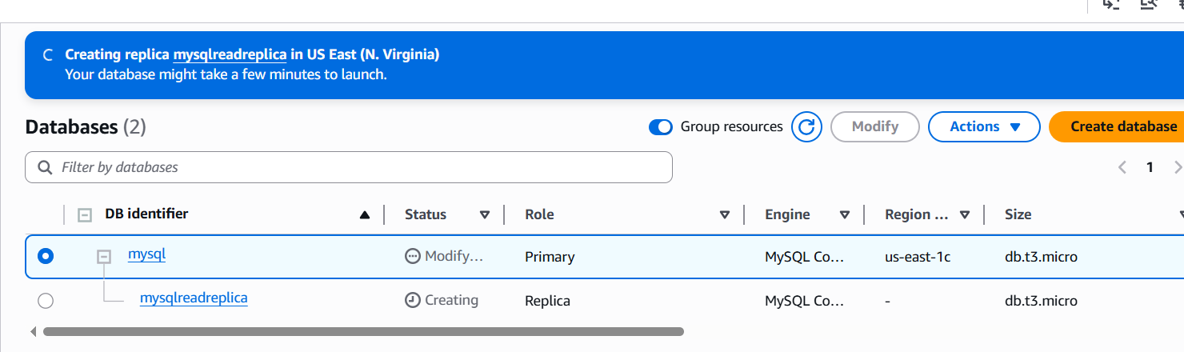  
  
All the data from primary DB is replicated to Read Replica DB, which will be readonly and we have Cress region replication we can create Read Replica DB in another region.

The-End